Implementing Single Sign-On (SSO) Between Zscaler and Microsoft Azure Active Directory

S.No | NAME | COLLEGE NAME | CONTACT
1. | NANDHINI S | SRI KRISHNA ADITHYA COLLEGE OF ARTS AND SCIENCE | 23bscs233nandhinis@skacas.ac.in
2. | DHANUSH S | SRI KRISHNA ADITHYA COLLEGE OF ARTS AND SCIENCE | 23bscs208dhanushs@skacas.ac.in
3. | KRISHNAMOORTHY M | SRI KRISHNA ADITHYA COLLEGE OF ARTS AND SCIENCE | 23bscs222krishnamoorthym@skacas.ac.in
4. | SURYA S | SRI KRISHNA ADITHYA COLLEGE OF ARTS AND SCIENCE | 23bscs259suryas@skacas.ac.in
5. | MADHUMITHA J | SRI KRISHNA ADITHYA COLLEGE OF ARTS AND SCIENCE | 23bscs226madhumithaj@skacas.ac.in

Project details

Title: Implementing Single Sign-On (SSO) Between Zscaler and Microsoft Azure Active Directory

AI-Enhanced User Protection (AIUP)

AI-enhanced user protection in the integration of Zscaler with Microsoft Azure Active Directory for Single Sign-On (SSO) introduces a more intelligent and adaptive security layer that goes beyond traditional authentication methods. Instead of relying solely on static credentials, AI continuously analyzes user identity, behavior, and contextual signals to ensure secure access. This approach strengthens the authentication process by identifying potential threats early and reducing the chances of unauthorized access, even when valid login credentials are used.

One of the key components of AI-driven protection is intelligent threat detection. Zscaler leverages machine learning algorithms to monitor network traffic and user activities in real time, identifying anomalies such as unusual login locations, abnormal access times, or suspicious IP addresses. When integrated with Azure Active Directory, these insights are combined with identity-based signals to create a comprehensive security framework. This allows organizations to detect and mitigate threats proactively rather than reacting after a breach occurs.

Another important aspect is User Behavior Analytics (UBA), where AI systems establish a baseline of normal user behavior and continuously compare current activities against it. If deviations are detected—such as excessive data downloads or access from unfamiliar devices—the system flags them as potential risks. This capability is especially useful in identifying insider threats or compromised accounts. By combining behavioral insights from both Zscaler and Azure AD, organizations gain deeper visibility into user actions and can enforce stricter controls when needed.

AI also enables adaptive authentication, which dynamically adjusts security requirements based on the calculated risk level of each login attempt. For low-risk scenarios, users can seamlessly access resources through SSO, while higher-risk situations may trigger additional verification steps such as Multi-Factor Authentication (MFA) or even block access entirely. This risk-based approach not only enhances security but also improves user experience by avoiding unnecessary authentication steps for trusted users, making the system both secure and efficient.

Finally, AI supports continuous monitoring and automated response within a Zero Trust framework. Even after successful authentication via Microsoft Azure Active Directory, user sessions are continuously evaluated for suspicious behavior. If any risk is detected, automated actions such as session termination, access restriction, or alert generation are triggered instantly. This ensures that security is maintained throughout the user session, providing a robust defense against evolving cyber threats and reinforcing a proactive, intelligent security posture.

Abstract:

This project focuses on implementing Single Sign-On (SSO) between Zscaler and Microsoft Azure Active Directory to provide a secure, seamless, and intelligent user authentication experience in modern enterprise environments. By integrating Zscaler’s cloud-based security platform with Azure Active Directory, the system enables centralized identity management and simplifies user access to applications while enforcing strong security controls. The solution leverages standard authentication protocols such as SAML and OpenID Connect to validate user identities and grant access based on predefined policies. In addition to basic SSO functionality, the project incorporates AI-enhanced user protection mechanisms, including intelligent threat detection, user behavior analytics, adaptive authentication, and real-time risk assessment, to identify and mitigate potential security threats proactively. This integration supports a Zero Trust security model by continuously verifying user identity, device posture, and contextual factors before and after access is granted. Furthermore, automated responses such as session termination, access restriction, and alert generation help minimize risks associated with compromised accounts or malicious activities. Overall, the project demonstrates how combining Zscaler with Microsoft Azure Active Directory can enhance both security and user experience by delivering scalable, efficient, and intelligent access control for cloud and enterprise resources.

The system leverages standard protocols like SAML and OpenID Connect and incorporates AI-driven security features such as adaptive authentication and real-time risk analysis to enhance protection. This approach supports a Zero Trust model, ensuring continuous verification of users and providing a balance between strong security and improved user experience

Use Case Scenarios:
Scenario 1: Secure Remote Access with SSO Integration
A remote employee attempts to access an internal enterprise application from a home network. Instead of logging in separately, the user is redirected to Azure Active Directory for authentication. After successful identity verification and device posture validation, Zscaler establishes a secure Zero Trust connection, allowing access only to the requested application without exposing the internal network.
Output:
• User authenticated via Single Sign-On (SSO) through Azure AD
• Secure, application-level access provided by Zscaler
• No direct exposure of internal network infrastructure
• Unauthorized users automatically denied access

☁️ Scenario 2: Seamless Access to Cloud Applications via SSO
An employee needs to access cloud-based business applications such as dashboards or collaboration tools. With SSO enabled between Zscaler and Microsoft Azure Active Directory, the user logs in once and gains secure access to multiple applications without repeated authentication. Zscaler enforces identity-based policies before allowing access.
Output:
• Single login enables access to multiple authorized applications
• Secure authentication handled by Azure AD
• Direct and encrypted connection to cloud applications via Zscaler
• Access restricted based on user identity and policies

🤖 Scenario 3: AI-Based Detection of Suspicious Login Activity
A login attempt is made from an unusual location or unknown device. The AI-enhanced security system integrated with Zscaler and Azure AD analyzes user behavior and identifies it as a potential risk. Based on the risk level, the system enforces adaptive authentication.
Output:
• AI detects abnormal login behavior in real time
• Multi-Factor Authentication (MFA) triggered automatically
• Access temporarily restricted until verification
• Alerts generated for administrators

🔄 Scenario 4: Continuous Session Monitoring in Zero Trust Model
After successful SSO login, the user continues to interact with enterprise applications. Zscaler continuously monitors session activity using AI and identity signals from Microsoft Azure Active Directory to detect any suspicious behavior during the session.
Output:
• Continuous verification of user activity
• Immediate detection of anomalies during active sessions
• Automatic session termination if risk is detected
• Ensures compliance with Zero Trust security principles

🛡️ Scenario 5: Role-Based Access Control Using Identity
An organization assigns different access levels based on user roles stored in Azure Active Directory. When users authenticate via SSO, Zscaler enforces role-based access policies to ensure users can only access permitted applications.
Output:
• Access granted based on user roles and identity
• Unauthorized application access restricted
• Centralized identity and policy management
• Improved security and operational efficiency

Stage-1

Title Of the Project: Implementing Single Sign-On (SSO) Between Zscaler and Microsoft Azure Active Directory

Overview:

The project focuses on implementing a modern identity-driven security framework by integrating Zscaler with Microsoft Azure Active Directory to enable secure and seamless Single Sign-On (SSO) for enterprise applications. Traditional authentication mechanisms often require multiple logins and rely on perimeter-based security, which assumes users inside the network are trustworthy. However, with the increasing adoption of remote work, cloud services, and mobile access, this model is no longer sufficient. The integration of Zscaler with Azure AD addresses these challenges by centralizing authentication and adopting a Zero Trust approach, ensuring that every user is continuously verified before accessing any resource.
The primary objective of this project is to provide secure and unified user authentication across multiple applications using SSO, without exposing internal systems. Instead of requiring users to log in separately to each application, the system authenticates users once through Azure Active Directory and grants access to authorized applications based on identity and policy enforcement. This approach improves user experience while reducing the risk of credential misuse and unauthorized access.
The system validates multiple security parameters during authentication, including user identity, device condition, login location, and organizational policies. Zscaler acts as a secure intermediary that enforces access control after successful authentication from Azure AD. Internal and cloud applications remain protected, as access is granted only to verified users through secure, identity-based connections, preventing direct exposure to the public internet.
To enhance security further, AI-Enhanced User Protection (AIUP) is incorporated into the system. AI and machine learning techniques continuously monitor user behavior and detect anomalies such as unusual login attempts, unfamiliar devices, or abnormal access patterns. When integrated with Microsoft Azure Active Directory, the system performs real-time risk assessment and can trigger adaptive authentication measures such as Multi-Factor Authentication (MFA) or temporarily restrict access based on the detected risk level.

Secure authentication combined with continuous monitoring ensures that only legitimate users can access enterprise resources. In case of suspicious activities, the system generates alerts for administrators and takes automated actions such as session termination or access restriction. This proactive security mechanism helps protect sensitive enterprise data and maintain system integrity.

Additionally, all communication between users and applications is encrypted to ensure data confidentiality and prevent interception. Logging and monitoring features track authentication events, user activities, and access patterns, providing valuable insights for auditing, compliance, and security analysis. These capabilities help organizations maintain transparency and control over their access management systems.

The solution supports seamless integration with enterprise applications, cloud platforms, and identity services, enabling a scalable and unified access management framework. Monitoring tools provide visibility into user access behavior, system performance, and potential security threats, helping administrators make informed decisions.

Scalability and reliability are achieved through Zscaler’s cloud-native architecture, which can efficiently handle a large number of users and authentication requests. Distributed infrastructure ensures high availability and consistent performance for users accessing applications from different locations.

Overall, this project demonstrates how integrating Zscaler with Microsoft Azure Active Directory for Single Sign-On (SSO) can provide secure, efficient, and user-friendly access to enterprise applications. By combining centralized identity management, Zero Trust principles, and AI-driven security mechanisms, organizations can significantly enhance both security posture and user experience in modern digital environments.

List of Vulnerability Table:

Practice Website:

S.no | Vulnerability Name | CWE - No
1 | Improper Ownership Management | CWE- 282
2 | Cleartext Storage of Sensitive Information in a Cookie | CWE-315
3 | Use of Unmaintained Third Party Components | CWE-1104
4 | Insufficient Entropy | CWE -331
5 | Unchecked Error Condition | CWE-391

6 | Embedded Malicious Code | CWE-506
7 | Missing Encryption of Sensitive Data | CWE-331
8 | Missing XML Validation | CWE -112
9 | Missing Critical Step in Authentication | CWE-304
10 | Insufficient Logging | CWE-778

REPORT: -

1) Vulnerability Name: Insecure Storage of Sensitive Information

CWE/CVE: CWE-922

OWASP/SANS Category: A01:2025 – Broken Access Control

Description:

Insecure storage of sensitive information refers to the practice of storing critical data such as passwords, personal details, financial records, and authentication tokens without adequate protection mechanisms like strong encryption or proper access controls. This vulnerability arises when data is kept in plain text, weakly encrypted formats, or exposed databases, making it easily accessible to unauthorized users or attackers. In systems integrated with identity platforms like Microsoft Azure Active Directory, insecure storage can lead to exposure of user credentials and session data, increasing the risk of account compromise and unauthorized access to enterprise applications.

Business Impact:

The insecure storage of sensitive information can lead to serious business consequences, including data breaches that result in financial losses due to regulatory fines, legal actions, and recovery costs. It can significantly damage an organization’s reputation and erode customer trust, especially if personal or confidential data is exposed. Additionally, attackers may gain unauthorized access to systems, leading to data theft, service disruption, or misuse of enterprise resources. Non-compliance with data protection regulations can further increase legal risks, while operational downtime during incident response can negatively impact productivity and business continuity.

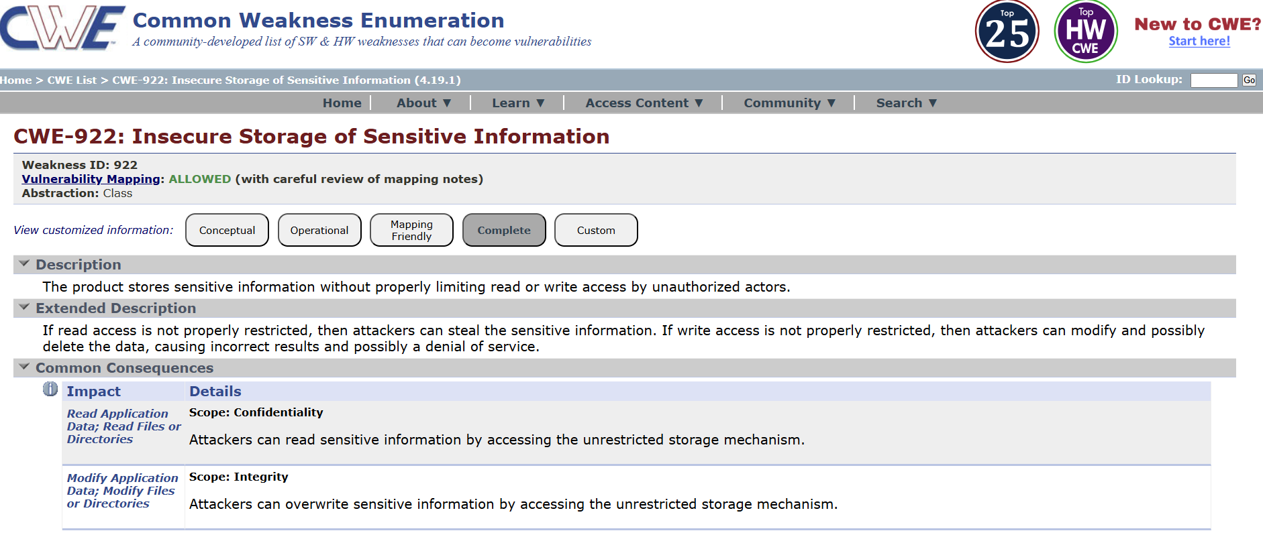

2) Vulnerability Name: Use of Hard-coded, Security-relevant Constants

CWE/CVE: CWE-547

OWASP/SANS Category: A02:2025-Security Misconfiguration

Description:

The use of hard-coded, security-relevant constants refers to embedding sensitive information such as passwords, API keys, encryption keys, or secret tokens directly within the source code of an application. This practice makes the information easily accessible to anyone who has access to the codebase, including developers, attackers, or anyone who can reverse-engineer the application. Hard-coded credentials are difficult to update or rotate, increasing the risk of long-term exposure. In environments integrated with identity systems like Microsoft Azure Active Directory, hard-coded secrets can compromise authentication mechanisms and allow unauthorized access to enterprise applications.

Business Impact:
Using hard-coded security constants can lead to severe security breaches if the embedded information is exposed, resulting in unauthorized system access, data theft, or service misuse. It increases the risk of credential leakage through code repositories, application logs, or reverse engineering. This can cause financial losses, reputational damage, and legal consequences due to non-compliance with security standards and regulations. Additionally, the lack of flexibility in updating hard-coded values can delay incident response and increase operational risks, ultimately affecting business continuity and trust.

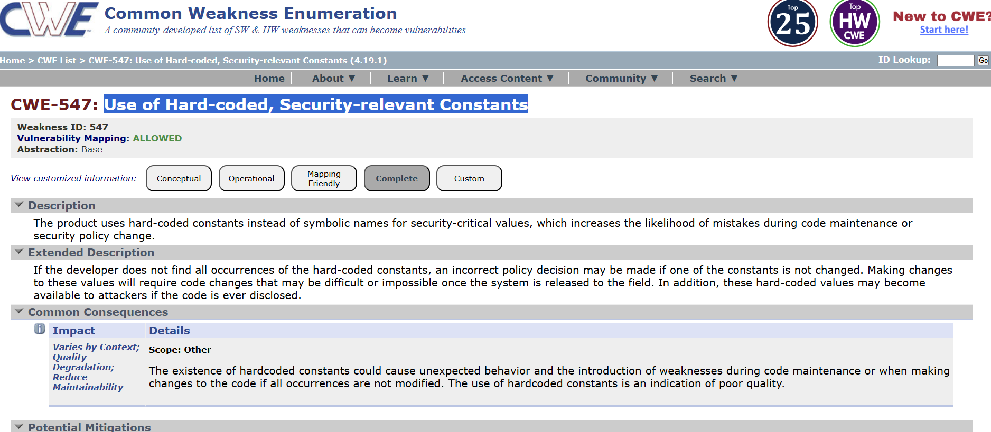

3) Vulnerability Name: Dependency on Vulnerable Third-Party Component

CWE/CVE: CWE-1395

OWASP/SANS Category: A03:2025-Software Supply Chain Failures

Description:

Dependency on vulnerable third-party components refers to the use of external libraries, frameworks, or software modules that contain known security vulnerabilities within an application or system. Modern applications often rely on third-party components to accelerate development, but if these components are outdated, unpatched, or insecure, they can introduce significant risks. Attackers can exploit these known vulnerabilities to gain unauthorized access, execute malicious code, or compromise system integrity. In environments integrated with identity platforms like Microsoft Azure Active Directory, a vulnerable component can weaken authentication flows or expose sensitive identity data, impacting the overall security of the system.

Business Impact:
Relying on vulnerable third-party components can lead to serious consequences such as data breaches, system compromise, and service disruptions. Exploitation of these vulnerabilities may result in unauthorized access to applications, loss of sensitive data, and financial damages due to recovery costs and regulatory penalties. It can also harm the organization’s reputation and customer trust, especially if the vulnerability leads to widespread security incidents. Additionally, identifying and fixing such issues may require urgent updates or system downtime, affecting business operations and productivity.

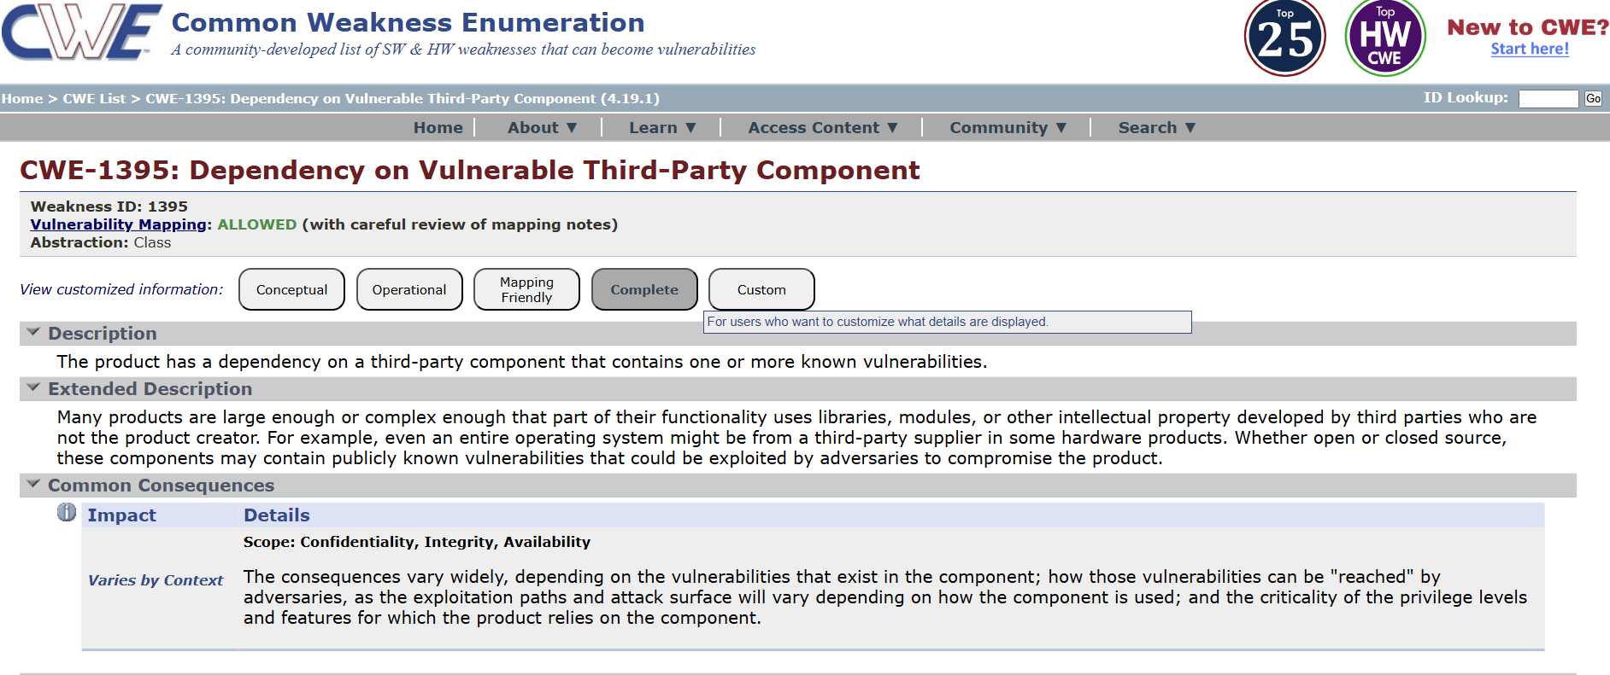

4) Vulnerability Name: Improper Verification of Cryptographic Signature
CWE/CVE: CWE-347
OWASP/SANS Category: A04:2025-Cryptographic Failures
Description:
Improper verification of cryptographic signatures occurs when an application fails to correctly validate the authenticity and integrity of digitally signed data, such as tokens, certificates, or messages. This vulnerability arises when signature checks are incomplete, incorrectly implemented, or bypassed, allowing attackers to forge or tamper with data without detection. In authentication systems that rely on signed tokens—such as integrations with Microsoft Azure Active Directory—improper verification can enable attackers to create fake authentication tokens, impersonate legitimate users, or gain unauthorized access to protected resources.
Business Impact:
This vulnerability can have serious consequences, including unauthorized access to enterprise systems, data breaches, and compromise of sensitive information. Attackers may exploit weak signature verification to bypass authentication and authorization controls, leading to system misuse or data manipulation. The resulting security incidents can cause financial losses, regulatory penalties, and reputational damage. Additionally, compromised trust in authentication mechanisms can disrupt business operations and require significant effort to remediate and restore system integrity.

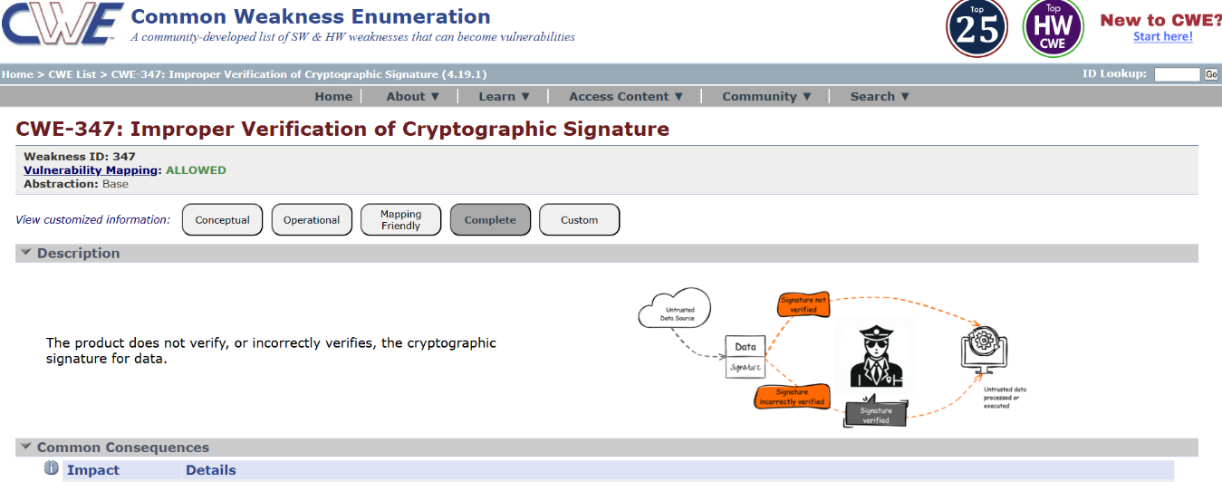

5) Vulnerability Name: Improper Neutralization of Directives in Statically Saved Code ('Static Code Injection')

CWE/CVE: CWE-96

OWASP/SANS Category: A05:2025 Injection

Description:
Improper Neutralization of Directives in Statically Saved Code, also known as Static Code Injection, occurs when an application stores user-supplied input that contains executable directives or code without properly sanitizing or neutralizing it. This stored content may later be executed in a different context, leading to unintended behavior or security compromise. Unlike dynamic injection, the malicious code is saved and triggered when the application processes or renders the stored data. This vulnerability often arises due to insufficient input validation and output encoding. In systems integrated with identity platforms like Microsoft Azure Active Directory, such weaknesses can allow attackers to inject malicious directives that may interfere with authentication flows, manipulate application behavior, or expose sensitive data.

Business Impact:
Static code injection can lead to serious security risks, including unauthorized access, data manipulation, and execution of malicious code within the application. Attackers may exploit this vulnerability to compromise user accounts, alter stored data, or disrupt system functionality. The impact can include financial losses due to data breaches, reputational damage from loss of customer trust, and potential legal consequences for failing to protect sensitive information. Additionally, remediation efforts may require significant time and resources, causing operational disruptions and affecting overall business continuity.

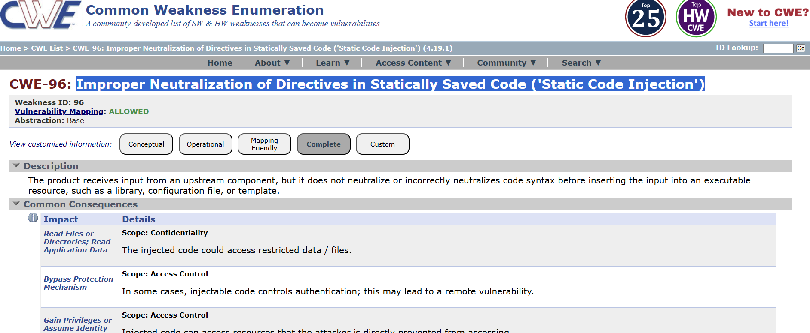

6) Vulnerability Name: Trust Boundary Violation

CWE/CVE: CWE-501

OWASP/SANS Category: A06:2025 Insecure Design

Description:
Trust Boundary Violation occurs when an application fails to properly validate or enforce security controls when data crosses different trust levels or system boundaries, such as between user input and backend systems, or between external services and internal applications. This vulnerability arises when untrusted data is treated as trusted without sufficient validation, allowing attackers to manipulate or inject malicious input. In systems integrated with identity platforms like Microsoft Azure Active Directory, a trust boundary violation can compromise authentication flows, enabling unauthorized access or privilege escalation if identity data is not properly verified across system boundaries.

Business Impact:
Trust boundary violations can lead to serious security risks, including unauthorized access to sensitive systems, data breaches, and privilege escalation attacks. Attackers may exploit weak validation between system components to bypass security controls and gain deeper access into enterprise environments. This can result in financial losses, reputational damage, and legal consequences due to compromised data. Additionally, such vulnerabilities can disrupt normal business operations and require extensive remediation efforts, impacting productivity and overall system reliability.

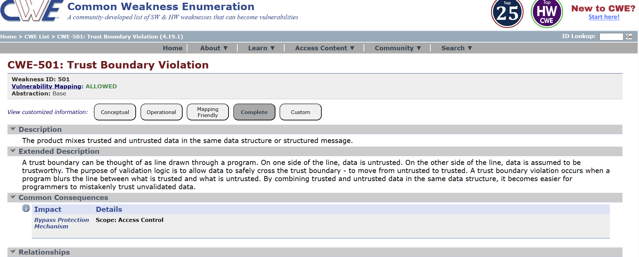
7) Vulnerability Name: Use of Single-factor Authentication
CWE/CVE: CWE-308
OWASP/SANS Category: A07:2025 Authentication Failures
Description:
Use of single-factor authentication refers to relying on only one method of user verification—typically a password—to grant access to systems or applications. While passwords are widely used, they are vulnerable to attacks such as phishing, credential stuffing, brute force attacks, and password reuse. When single-factor authentication is used without additional security layers, attackers who obtain valid credentials can easily gain unauthorized access. In environments integrated with identity platforms like Microsoft Azure Active Directory, relying solely on single-factor authentication weakens identity security and undermines modern Zero Trust principles.
Business Impact:
The use of single-factor authentication significantly increases the risk of account compromise and unauthorized access to enterprise applications and sensitive data. Successful attacks can lead to data breaches, financial losses, and operational disruptions. Organizations may also face compliance violations, reputational damage, and loss of customer trust due to inadequate authentication controls. Additionally, recovering from compromised accounts requires time and resources, affecting productivity and increasing security management costs.

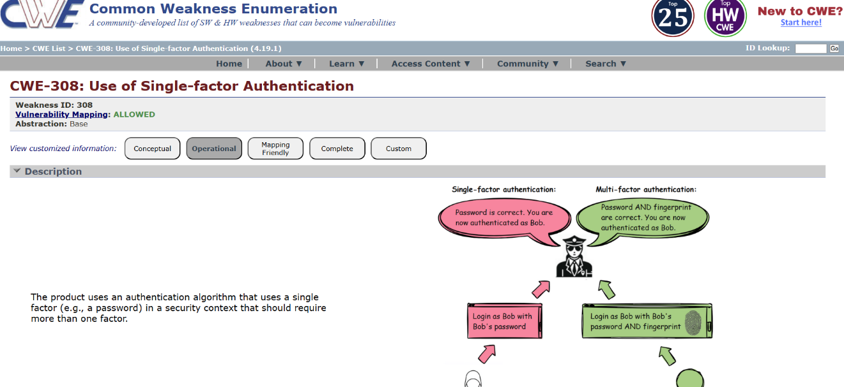

8) Vulnerability Name: Embedded Malicious Code

CWE/CVE: CWE-506

OWASP/SANS Category: A08:2025 Software or Data Integrity Failures

Description:
Embedded malicious code refers to hidden or intentionally inserted harmful code within legitimate applications, scripts, or software components. This malicious code may be introduced through compromised third-party libraries, insider threats, or unauthorized modifications to source code. Once embedded, the code can execute harmful actions such as stealing sensitive data, creating backdoors, or manipulating system behavior. In environments that integrate identity and access management systems like Microsoft Azure Active Directory, embedded malicious code can target authentication processes, capture credentials, or bypass security controls, leading to severe system compromise.

Business Impact:
The presence of embedded malicious code can result in significant security incidents, including data breaches, unauthorized access, and loss of intellectual property. It can disrupt normal business operations by degrading system performance or causing service outages. Financial losses may occur due to incident response, remediation efforts, regulatory fines, and potential legal actions. Additionally, such incidents can severely damage an organization’s reputation and erode customer and stakeholder trust, impacting long-term business viability.

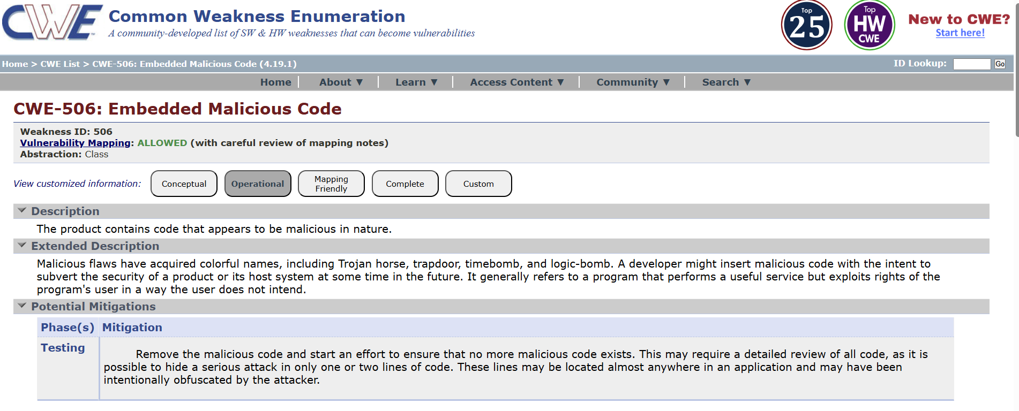
9) Vulnerability Name: Insufficient Logging

CWE/CVE: CWE-778

OWASP/SANS Category: A09:2025 Security Logging & Alerting Failures

Description:
Insufficient logging refers to the lack of adequate recording of security-relevant events such as user logins, access attempts, configuration changes, and system errors. When applications or security systems do not generate detailed or centralized logs, it becomes difficult to detect suspicious activities, investigate incidents, or trace the root cause of security breaches. In environments integrated with identity platforms like Microsoft Azure Active Directory, insufficient logging can prevent organizations from identifying unauthorized access attempts, misuse of credentials, or abnormal authentication behavior.

Business Impact:
Insufficient logging significantly weakens an organization’s security posture by delaying the detection and response to security incidents. Undetected attacks can persist for long periods, leading to extensive data loss and system compromise. This can result in financial losses, compliance violations, and reputational damage due to the inability to provide audit trails or incident evidence. Additionally, the lack of visibility into system activities increases investigation time and operational costs, impacting business continuity and overall risk management.

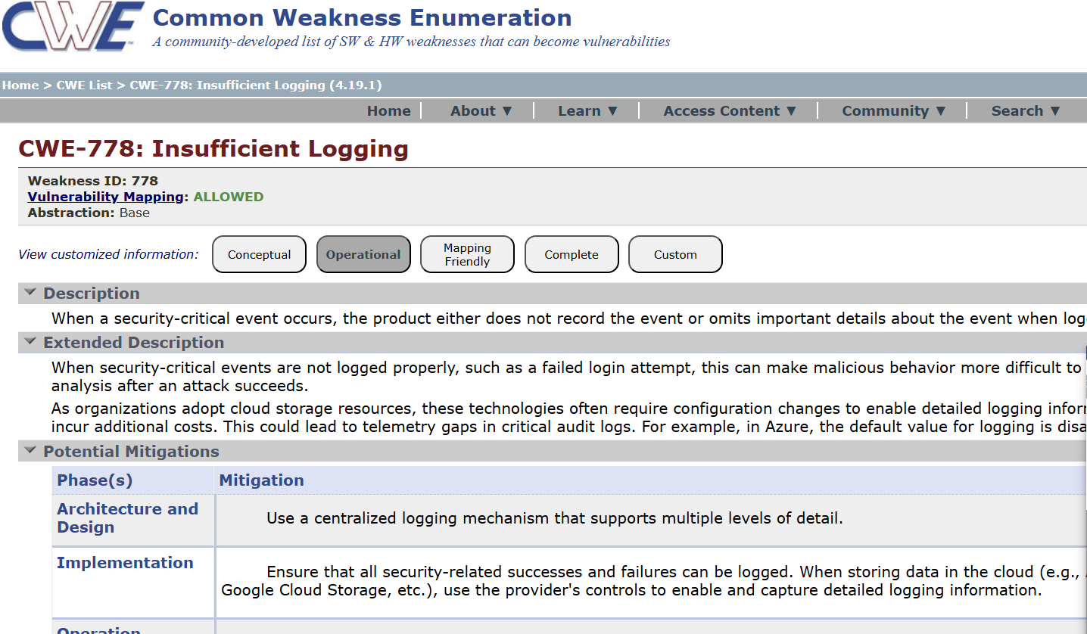

10) Vulnerability Name: Missing Custom Error Page

CWE/CVE: CWE-756

OWASP/SANS Category: A10:2025 Mishandling of Exceptional Conditions

Description:
Missing custom error pages refer to the use of default system-generated error messages instead of properly designed, user-friendly error pages. Default error pages often reveal sensitive technical details such as server information, stack traces, application paths, or configuration data. This information can be leveraged by attackers to understand the underlying system architecture and identify potential vulnerabilities. In applications integrated with identity platforms like Microsoft Azure Active Directory, missing custom error handling may expose authentication or authorization details during login failures, increasing the risk of targeted attacks.

Business Impact:
The absence of custom error pages can lead to increased security risks by unintentionally disclosing internal system information to attackers. This may facilitate further exploitation, resulting in unauthorized access or data breaches. From a business perspective, such exposure can cause reputational damage, loss of customer trust, and potential compliance issues if sensitive information is leaked. Additionally, poor error handling degrades user experience, leading to confusion or frustration for legitimate users, which can negatively impact service reliability and overall business credibility.

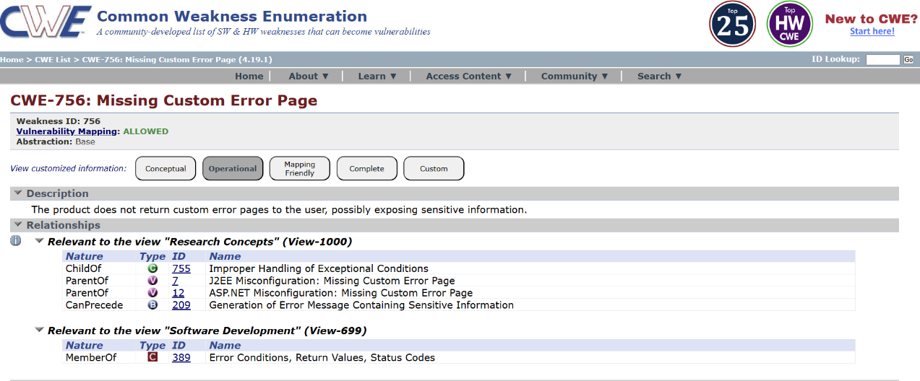

This is stage 1 in the context of web application testing and security we take help from
OWASP top 10 to understand them. The OWASP Top 10 is a widely recognized list of the most critical web application security risks. Understanding these risks is essential for ensuring the security of web applications.

Stage 2

Overview :-

Stage 2 of the project focuses on the practical implementation of Single Sign-On (SSO) between Zscaler and Microsoft Azure Active Directory. In this stage, the required prerequisites are configured, including setting up the identity provider in Azure AD and registering Zscaler as a trusted service provider. Secure authentication protocols such as SAML are implemented to establish a trust relationship between the two platforms. This ensures that user authentication requests are securely redirected to Azure AD and validated before access is granted.

The next phase of this stage involves configuring user attributes, group mappings, and access policies. User identities and roles defined in Azure Active Directory are synchronized with Zscaler to enforce identity-based access control. This allows Zscaler to apply security policies based on authenticated user information, ensuring that only authorized users can access permitted applications and services. Testing is conducted to verify successful authentication flows, correct attribute exchange, and seamless SSO experience across applications.

Nessus can be effectively used to assess the security posture of environments where Single Sign-On (SSO) is implemented between Zscaler and Microsoft Azure Active Directory. In such architectures, Nessus helps identify vulnerabilities across identity infrastructure, authentication services, application endpoints, and supporting network components. It can scan identity-related servers, cloud-connected systems, and application access points to ensure that the SSO integration does not introduce security weaknesses. Scans can be performed on individual hosts, networks, or specific services involved in authentication and access control, either manually or on a scheduled basis.

Step-by-Step Working of Nessus in the SSO Environment

- Nessus connects to target systems involved in the SSO workflow—such as application servers, identity connectors, or supporting network components—using protocols like TCP, UDP, and ICMP.
- It sends probes to identify operating systems, open ports, and services that support authentication and access management.
- Nessus executes vulnerability assessment plugins to detect misconfigurations, outdated services, weak encryption settings, or exposed authentication endpoints that could affect the security of the Zscaler–Azure AD SSO integration.
- After the scan, Nessus generates detailed reports highlighting identified vulnerabilities, their severity levels, potential security risks, and recommended remediation steps to strengthen identity and access security.
Nessus is a valuable tool for security teams implementing SSO between Zscaler and Azure AD, as it helps validate that authentication components, access gateways, and supporting infrastructure are securely configured. The reports generated by Nessus assist administrators in prioritizing fixes and maintaining compliance with security best practices, thereby reducing the risk of unauthorized access or identity-based attacks.

Benefits of Using Nessus for SSO Security Assessment

● Comprehensive vulnerability coverage: Nessus offers extensive plugins that detect vulnerabilities in operating systems, applications, and services supporting identity and access management.
● Ease of use: Its intuitive interface allows administrators to easily configure scans for SSO-related components.
● Detailed reporting: Nessus provides clear insights into vulnerabilities, their impact on authentication security, and actionable remediation steps.
● Scalability: It can assess small SSO deployments as well as large enterprise environments integrating Zscaler and Azure AD.
● Flexibility: Scans can be run on demand or scheduled regularly to continuously monitor the security of the SSO implementation.
Overall, Nessus—developed by Tenable—plays an important role in strengthening the security of Single Sign-On deployments by identifying vulnerabilities early and supporting a proactive security approach. When combined with Zscaler and Azure AD, it helps ensure a secure, reliable, and resilient identity-based access framework.

Target website :- http://testfire.net/
Target ip address:- 65.61.137.117

s.no | Vulnerability name | Severity | plugins
1 | TLS Version 1.0 Protocol  Detection | MEDIUM | 104743
2 | TLS Version 1.1 Protocol  Deprecated | MEDIUM | 157288
3 | SSL/TLS Diffie-Hellman Modulus  <= 1024 Bits (Logjam) | LOW | 83875
4 | ICMP Timestamp Request Remote  Date Disclosure | INFO | 10114
5 | Additional DNS Hostnames | INFO | 46180
6 | Apache Tomcat Detection | INFO | 39446
7 | Common Platform Enumeration  (CPE) | INFO | 45590
8 | Device Type | INFO | 54615
9 | HSTS Missing From HTTPS Server | INFO | 84502
10 | HTTP Server Type and Version | INFO | 10107
List of vulnerability:-

REPORT: -

- Vulnerability Name: - 104743 - TLS Version 1.0 Protocol Detection Severity: - MEDIUM
Plugin: - 104743

Port: - 443
Description: - The remote service accepts connections encrypted using TLS 1.0. TLS 1.0 has a number of cryptographic design flaws. Modern implementations of TLS 1.0 mitigate these problems, but newer versions of TLS like 1.2 and 1.3 are designed against these flaws and should be used whenever possible.

As of March 31, 2020, Endpoints that aren’t enabled for TLS 1.2 and higher will no longer function properly with major web browsers and major vendors.
PCI DSS v3.2 requires that TLS 1.0 be disabled entirely by June 30, 2018, except for POS POI terminals (and the SSL/TLS termination points to which they connect) that can be verified as not being susceptible to any known exploits.
Solution: - Enable support for TLS 1.2 and 1.3, and disable support for TLS 1.0.
Business Impact: -Continued use of TLS 1.0's encryption, known for its inherent cryptographic flaws, exposes the organization to heightened security risks, increasing the likelihood of data breaches and cyberattacks. This vulnerability jeopardizes compliance with industry standards, specifically PCI DSS v3.2, which mandates the complete cessation of TLS 1.0 use. Non- compliance risks regulatory penalties and erodes customer trust. Moreover, endpoints that lack support for TLS 1.2 and higher will experience impaired functionality with major web browsers and vendors, potentially leading to lost business opportunities and damage to the organization's reputation. Addressing this vulnerability is imperative to mitigate these multifaceted risks and maintain a secure and trustworthy online presence.

Vulnerability Name: - 157288 - TLS Version 1.1 Protocol Deprecated Severity: - MEDIUM
Plugin: - 157288

Port: - 443
Description: - The remote service accepts connections encrypted using TLS 1.1. TLS 1.1 lacks support for current and recommended cipher suites. Ciphers that support encryption before MAC computation, and authenticated encryption modes such as GCM cannot be used with TLS 1.1 As of March 31, 2020, Endpoints that are not enabled for TLS 1.2 and higher will no longer function properly with major web browsers and major vendors.
Solution: - Enable support for TLS 1.2 and/or 1.3, and disable support for TLS 1.1.

Business Impact: -The continued use of TLS 1.1 with its lack of support for modern cipher suites and advanced encryption methods jeopardizes the organization's security posture, increasing vulnerability to cyber threats and potential data breaches. Additionally, endpoints not upgraded to support TLS 1.2 and higher will encounter compatibility issues with major web browsers and vendors, impacting user experience and potentially leading to missed business opportunities. Swift remediation of this vulnerability is essential to mitigate security risks and ensure seamless interactions with web browsers and vendors, preserving the organization's reputation and operational efficiency.

Vulnerability Name: - 83875 - SSL/TLS Diffie-Hellman Modulus <= 1024 Bits (Logjam) Severity: - LOW
Plugin: - 83875

Port: - 443
Description: - The remote host allows SSL/TLS connections with one or more Diffie-Hellman moduli less than or equal to 1024 bits. Through cryptanalysis, a third party may be able to find the shared secret in a short amount of time (depending on modulus size and attacker resources). This may allow an attacker to recover the plaintext or potentially violate the integrity of connections.
Solution: - Reconfigure the service to use a unique Diffie-Hellman moduli of 2048 bits or greater.
Business Impact: - Allowing SSL/TLS connections with weak Diffie-Hellman moduli raises security concerns. An attacker with sufficient resources and computing power could compromise the shared secret relatively quickly, potentially leading to the decryption of sensitive data or the violation of connection integrity. While the severity is low, the risk of data breaches and integrity compromise should not be underestimated, and it is essential to address this vulnerability to maintain data security and user trust.

Vulnerability Name: - 10114 - ICMP Timestamp Request Remote Date Disclosure Severity: - INFO
Plugin: - 10114

Port: - 0
Description: - The remote host answers to an ICMP timestamp request. This allows an attacker to know the date that is set on the targeted machine, which may assist an unauthenticated, remote attacker in defeating time-based authentication protocols.
Timestamps returned from machines running Windows Vista / 7 / 2008 / 2008 R2 are deliberately incorrect, but usually within 1000 seconds of the actual system time.
Solution: - Filter out the ICMP timestamp requests (13), and the outgoing ICMP timestamp replies (14).
Business Impact: -This does not pose an immediate threat to business operations or data security. This vulnerability allows external parties to request the system's date and time information remotely. While it does not present a significant risk, it could potentially be used by attackers for reconnaissance purposes. Therefore, it is advisable to address this vulnerability as part of a broader security posture to reduce the risk of unauthorized data gathering and protect against potential future threats.

Vulnerability Name: - 46180 - Additional DNS Hostnames Severity: - INFO
Plugin: - 46180

Port: - 0
Description: - Hostnames different from the current hostname have been collected by miscellaneous plugins. Nessus has generated a list of hostnames that point to the remote host. Note that these are only the alternate hostnames for hosts discovered on a web server.

Different web servers may be hosted on name-based virtual hosts.
Solution: - If you want to test them, re-scan using the special vhost syntax, such as : www.example.com [192.0.32.10]
Business Impact: -This does not pose an immediate threat to business operations or data security. It indicates the discovery of hostnames that are associated with the remote host, particularly in cases of web servers utilizing name-based virtual hosts. While not a security risk on its own, it could be useful for understanding the server's configuration and infrastructure.
Organizations should consider this information as part of their network documentation but do not need to take immediate action to mitigate it as a security threat.

Vulnerability Name: - 39446 - Apache Tomcat Detection Severity: - INFO
Plugin: - 39446

Port: - 80
Description: -Nessus was able to detect a remote Apache Tomcat web server.

Solution: - n/a
Business Impact: -Is an informational finding that identifies the presence of a remote Apache Tomcat web server. While this information itself does not indicate a security threat or impact on business operations, it can be useful for network administrators and security professionals to be aware of the technologies in use on their network. Understanding the presence of an Apache Tomcat server can be valuable for maintaining and securing web applications, but it does not require immediate action to mitigate a security risk.

Vulnerability Name: - 45590 - Common Platform Enumeration (CPE) Severity: - INFO
Plugin: - 45590

Port: - 0
Description: - By using information obtained from a Nessus scan, this plugin reports CPE (Common Platform Enumeration) matches for various hardware and software products found on a host.
Note that if an official CPE is not available for the product, this plugin computes the best possible CPE based on the information available from the scan.

Solution: - n/a
Business Impact: - This provides insights into hardware and software products identified on a host through a Nessus scan. It reports CPE matches, which are standardized identifiers for these products. This information is valuable for asset management and inventory purposes. While it doesn't signify a security threat, it aids administrators in understanding the components within their network, contributing to effective resource management and facilitating future system maintenance.

Vulnerability Name: - Device Type Severity: - INFO
Plugin: - 54615

Port: - 0
Description: - Based on the remote operating system, it is possible to determine what the remote system type is (eg: a printer, router, general-purpose computer, etc).

Solution: -
Business Impact: - It allows for the identification of the remote system type, such as a printer, router, or general-purpose computer, based on the remote operating system. While this doesn't pose a direct security threat, it offers valuable insights for network administrators to better understand and classify the devices in their network. This information aids in network

management, optimization, and ensures that the right security measures are in place for each device type.

Vulnerability Name: - 84502 - HSTS Missing From HTTPS Server Severity: - INFO
Plugin: - 84502

Port: - 443
Description: -The remote HTTPS server is not enforcing HTTP Strict Transport Security (HSTS). HSTS is an optional response header that can be configured on the server to instruct the browser to only communicate via HTTPS. The lack of HSTS allows downgrade attacks, SSL- stripping man-in-the-middle attacks, and weakens cookie-hijacking protections.
Solution: - Configure the remote web server to use HSTS.
Business Impact: -Indicates that the remote HTTPS server does not enforce HTTP Strict Transport Security (HSTS). HSTS is a crucial security feature that, when configured on the server, instructs web browsers to communicate exclusively via HTTPS, enhancing security. The absence of HSTS potentially exposes the server to downgrade attacks, SSL-stripping man-in-the- middle attacks, and weakens protections against cookie hijacking, posing risks to data confidentiality and user security. Enabling HSTS is essential to ensure a higher level of protection for data transmitted between clients and the server.

Vulnerability Name: - 10107 - HTTP Server Type and Version Severity: - INFO
Plugin: - 10107

Port: - 443

Description: - This plugin attempts to determine the type and the version of the remote web server.

Solution: - N/A
Business Impact: -This relates to the identification of the remote web server's type and version. While this issue doesn't pose an immediate security threat, it can provide valuable information to potential attackers about the server's software stack. Knowledge of the server type and version may aid attackers in exploiting known vulnerabilities specific to that software, making it important to restrict such information from being easily accessible to enhance the server's overall security posture.

Report: -

Stage-3

Title: - Implementing Single Sign-On (SSO) Between Zscaler and Microsoft Azure Active Directory

Zero Trust Network Access (ZTNA) in an SSO-Based Architecture

Zero Trust Network Access (ZTNA) is a modern security framework that enables secure access to enterprise applications based on strict identity verification and access control policies. When integrated with Single Sign-On (SSO), ZTNA ensures that users authenticate once through a trusted identity provider and gain secure, controlled access only to authorized applications. Unlike traditional Virtual Private Networks (VPNs), which provide broad network-level access, ZTNA follows the principle of “never trust, always verify.” Access is granted only after validating the user’s identity, authentication context, and device posture, making it ideal for today’s remote and cloud-based environments.
In an SSO implementation using Zscaler and Microsoft Azure Active Directory, ZTNA eliminates the concept of a trusted internal network. Applications are hidden from the public internet, and users never connect directly to the internal network. Instead, secure, application-specific connections are established dynamically. This approach significantly reduces the attack surface and prevents threats such as unauthorized access and lateral movement within the network.

ZTNA Access Cycle with Zscaler and Azure AD SSO:

Single Sign-On (SSO) is a critical component in modern cybersecurity frameworks, enabling users to access multiple applications with a single set of credentials. When integrating Zscaler with Microsoft Azure Active Directory, organizations can establish a secure and seamless authentication process. This integration supports Zero Trust Network Access (ZTNA), ensuring that users are continuously verified before gaining access to enterprise resources.

The ZTNA access cycle begins when a user attempts to access a protected application through Zscaler. Instead of granting immediate access, Zscaler redirects the authentication request to Azure Active Directory. Azure AD acts as the identity provider (IdP), validating the user’s credentials using secure protocols such as SAML (Security Assertion Markup Language). This ensures that authentication is handled centrally, reducing the risks associated with multiple login systems.

Once the user is authenticated, Azure AD sends a secure token back to Zscaler, confirming the user’s identity and access permissions. Zscaler then evaluates additional security policies, such as device posture, location, and user behavior, before granting access to the requested application. This layered verification aligns with the principles of Zero Trust, where no user or device is automatically trusted, even after successful authentication.

Implementing SSO between Zscaler and Azure AD also improves user experience and operational efficiency. Employees can access cloud and internal applications without repeatedly entering credentials, reducing login fatigue and increasing productivity. At the same time, IT administrators benefit from centralized identity management, simplified access control, and enhanced visibility into user activities across the network.

In conclusion, integrating Zscaler with Azure Active Directory for SSO strengthens both security and usability within an organization. By combining identity-based authentication with continuous access evaluation, businesses can effectively implement a Zero Trust architecture. This approach not only protects sensitive data but also ensures a smooth and secure user experience in today’s dynamic digital environments.

Zscaler then enforces policies based on this data, including:
- Identity-Based Access: Policies are built around user and group identities, not IP addresses.
- Application Segmentation: Users are granted access to specific applications, not entire subnets.
- Least Privilege Access: Ensures users have the minimum level of access required to perform their jobs.

The Zscaler ZTNA Cycle
The Zscaler ZTNA cycle is the practical application of the ZTNA principles using the Zscaler cloud. The cycle typically consists of the following steps:
- User Login and Authentication: A user attempts to access an internal application. They are redirected to their organization's Identity Provider (IdP) for authentication and MFA.
- Device Posture Check (Integration): Zscaler checks with integrated endpoint protection tools to ensure the device is compliant with security policies.
- Policy Lookup and Decision: The Zscaler cloud evaluates the request against the defined access policies. It verifies that the user, device, and context (time, location) are authorized for that specific application.
- Establishing the Micro-tunnel: Once authorized, the Zscaler cloud instructs the user's Zscaler Client Connector and the appropriate Zscaler App Connector in the data center to establish an encrypted connection. The user is now connected to the application.
- Traffic Inspection (Optional): For sanctioned applications, Zscaler can optionally inspect the traffic for data loss prevention (DLP) or to detect malware.
- Logging and Analytics: All activity is logged in the Zscaler cloud portal for reporting, threat hunting, and compliance.

MISP (Malware Information Sharing Platform) Integration
While Zscaler is a primary access control tool, it can be enhanced by integrating with threat intelligence platforms like MISP.
- Threat Intelligence Feed: MISP can aggregate and share threat intelligence about malicious domains, IPs, and URLs. This list of indicators of compromise (IOCs) can be fed into Zscaler's cloud.
- Proactive Blocking: If a user, even one authorized by ZPA, attempts to access a known malicious site that has been flagged by the MISP feed, Zscaler Internet Access (ZIA) can block the request, preventing a potential infection.
- Enhanced Visibility: Security teams can use MISP to cross-reference Zscaler logs. If a user's behavior is anomalous, the team can check MISP to see if the destination IP or domain is associated with a known threat actor or campaign.
  - Your College Network Information
This infrastructure presents a large attack surface, especially with the need for remote learning and

administrative access. The network includes:

- Core routers and switches
- Distribution routers and switches
- Wireless access points
- Firewalls and Intrusion Detection Systems (IDS)
- Internal Application Servers: Hosting the student information system, library resources, research data repositories, and administrative portals.
- Legacy VPN Concentrator: Currently providing broad network-level access for faculty and staff working remotely.
The need for ZTNA arises from the limitations of the current VPN model:
- Over-permissioned Access: Once on the VPN, a faculty member's compromised laptop could potentially scan and attack the entire internal network (lateral movement).
- Hidden Applications: Some research applications need to be accessed by external collaborators without granting them full network access.
- User Experience: The legacy VPN can be slow and cumbersome, often requiring users to route all their internet traffic through the university.
  - How you think you deploy ZTNA using Zscaler in your college
To deploy Zscaler ZTNA (ZPA) in your college, you would start by identifying the specific applications that need to be secured and the user groups that need access to them. This is a shift from securing the network to securing access to applications.

The plan would need to include the following:
- Application Discovery: Catalog all internal applications (e.g., ERP, library system, research servers, file shares) and identify which ones are currently exposed via the VPN.
- User Segmentation: Define user groups (e.g., Students, Faculty - Research, Faculty - Admin, IT Staff, External Collaborators) and the specific applications each group needs.
- Deploying Zscaler App Connectors: Install lightweight App Connector VMs in the university's data center. These connectors will establish outbound connections to the Zscaler cloud, making the application servers invisible to the public internet.
- Integrating Identity Provider: Connect Zscaler to the university's existing Identity Provider (e.g., Microsoft Azure AD) to leverage current usernames, passwords, and MFA policies.
- Configuring Access Policies: Create granular policies in the Zscaler admin portal. For example: "The 'Faculty' group can access the 'ERP Application' from any device that has antivirus enabled, after MFA."

- Deploying Zscaler Client Connector: Students, faculty, and staff will install the Zscaler Client Connector on their laptops and mobile devices. This small client intelligently routes traffic for private applications through ZPA and public traffic through ZIA.

Threat Intelligence

In the context of Zscaler and ZTNA, threat intelligence is used to understand who is trying to access what, and from where. It helps move beyond simple identity checks to a more contextual understanding of risk.
Sources include:
- Zscaler Cloud Logs: Internal logs provide real-time data on who is accessing which applications, from which locations, and on what devices.
- External Threat Feeds (MISP): Information about new malware campaigns, phishing kits, or command-and-control servers being used by attackers.
- Identity Provider Logs: Anomalies in login attempts, such as a user logging in from two geographically impossible locations in a short time, can signal a compromised account.
This intelligence is used for:
- Adaptive Access Control: If threat intelligence suggests a user's location is high-risk, Zscaler can step-up authentication requirements or block access entirely.
- Hunting for Compromised Accounts: Analysts can use Zscaler logs to see if a user is suddenly accessing applications they never have before, which could be a sign of credential theft.
- Blocking Malicious Communication: Threat intelligence feeds can be used by Zscaler Internet Access (ZIA) to block outbound connections to known malicious sites, even if they originate from a user inside the university.

Incident Response (Adapted for ZTNA)
Incident response in a ZTNA model is faster and more targeted because the environment is inherently more controlled.
- Detection: The SOC team detects an anomaly. For example, a faculty account is downloading an unusually high volume of data from a research server at 3 AM. Zscaler logs provide the exact details: the user, the device, the application, and the amount of data transferred.
- Containment: The SOC team can instantly isolate the user. In the Zscaler portal, they can simply deactivate that user's access or block their specific device. Because there is no network- level access, this action immediately severs all connections to every application, preventing lateral movement.
- Eradication: The compromised device is taken offline for malware scanning and cleaning by the IT helpdesk.
- Recovery: Once the device is clean and the user's password is reset, the Zscaler policy is re- enabled, granting the user access again.
- Post-incident review: The security team analyzes the logs to understand how the account was compromised (e.g., a phishing email) and updates Zscaler policies, perhaps by adding a block for similar malicious domains or tightening access rules for that specific research application.
Benefits of this incident response approach:
- Near-Instant Containment: Actions take seconds in a cloud dashboard, not minutes or hours configuring firewall rules.
- No Lateral Movement: The attacker is contained to the single compromised application, protecting the rest of the university's network.

- Granular Forensics: Zscaler provides a detailed audit trail of every connection, making investigations faster and more accurate.
- Compliance: This model helps demonstrate compliance with data protection regulations by proving that access to sensitive student or research data is tightly controlled and audited.

Understanding about the tool (Zscaler ZPA)
Zscaler Private Access (ZPA) is a cloud service that embodies the ZTNA principle of "connect a user to an app, not the network." Here are the key things to understand:
- It is "Application-Centric," Not "Network-Centric": You define policies based on applications (e.g., "SAP Server 01"), not network constructs like IP subnets. This aligns security with how businesses actually operate.
- It Hides the Network: ZPA uses App Connectors inside your data center that only
make outbound connections to the Zscaler cloud. Your internal servers never need to open inbound firewall ports, making them invisible to port scanners and attackers on the internet.
- It uses a "Dark Cloud" Approach: To an external scanner, the organization's applications simply don't exist. They only become visible to authorized users after a multi-step verification process.
- It Provides a Superior User Experience: Users don't have to mess with clunky VPN clients. The Zscaler Client Connector works silently in the background. For web apps, access can even be agentless, requiring only a modern browser.
- It is Inherently Scalable: Because it's a cloud service, ZPA scales instantly to handle thousands of concurrent users, unlike a legacy VPN appliance that needs to be manually upgraded.

Conclusion: -

In conclusion, exploring the realm of AI for web security using IBM QRadar has been an insightful journey through various stages.

In Stage 1, understanding web application testing unveiled the critical importance of assessing vulnerabilities and ensuring the security of web-based systems. This foundational knowledge served as a cornerstone for comprehending the subsequent stages.

Stage 2 delved into the intricacies of Nessus reports, emphasising the significance of detailed vulnerability assessments. Analysing these reports provided valuable insights into potential threats, enabling informed decision-making for robust security measures.

Stage 3 introduced the pivotal concept of Zero Trust Network Access (ZTNA) and its implementation using Zscaler Private Access (ZPA). It demonstrated a paradigm shift from traditional VPN-based network access to secure, identity-based user-to-application connectivity. The solution showcased the power of hiding internal applications from the internet, enforcing granular access policies, and eliminating lateral movement. This underscores the need for modern, proactive cybersecurity strategies in an era of remote work and cloud adoption
Considering the future scope, Stage 1 illuminated the evolving landscape of web application testing. With advancements in AI, there is a promising avenue for more sophisticated testing methodologies, ensuring even higher levels of security for web applications.

Stage 2 highlighted the future trajectory of the testing process, indicating a shift towards more automation and integration of AI-driven tools. This evolution promises quicker, more accurate vulnerability assessments, enhancing overall cybersecurity postures.

Stage 3 illuminated the future potential of Zero Trust Network Access (ZTNA) and Zscaler technologies. With AI integration and machine learning, these systems are poised to become more intelligent and adaptive, enabling real-time risk assessment based on user behavior and device posture. Enhanced automation in policy enforcement, predictive analytics for threat detection, and improved scalability are anticipated, empowering organizations to stay ahead of sophisticated cyber threats in an increasingly distributed world.
In essence, the project not only provided a deep understanding of the current state zero trust using ZSCALER but also offered a glimpse into the exciting future of cybersecurity. Embracing these advancements will be crucial for organisations aiming to fortify their digital landscapes in the face of ever-evolving cyber threats.

Future Scope: -

Future of web application testing

The future of WAT is bright, as web applications become increasingly complex and sophisticated. Organizations are increasingly reliant on web applications to conduct business, and they need to be confident that their web applications are secure and reliable.

Here are some of the key trends that are expected to shape the future of WAT:

- Increased focus on security: Security is a top priority for all organizations, and WAT is essential for identifying and mitigating security vulnerabilities. In the future, we can expect to see even more emphasis on security testing, as web applications become increasingly targeted by cyberattacks.
- Rise of artificial intelligence (AI) and machine learning (ML): AI and ML are already being used in WAT, and their role is expected to grow in the future. AI and ML can be used to automate repetitive tasks, such as test case generation and execution. They can also be used to identify complex patterns and anomalies that may be difficult to detect with traditional testing methods.
- Shift to cloud-based testing: More and more organizations are moving their web applications to the cloud. This trend is driving the growth of cloud-based WAT platforms. Cloud-based testing platforms offer a number of advantages, such as scalability, flexibility, and cost-effectiveness.
- Increased focus on user experience (UX) testing: UX testing is essential for ensuring that web applications are easy to use and meet the needs of users. In the future, we can expect to see more focus on UX testing, as organizations increasingly recognize the importance of providing a positive user experience.

Future scope of the testing process

The future scope of the testing process is bright, as software becomes increasingly complex and sophisticated. Organisations are increasingly reliant on software to conduct business, and they need to be confident that their software is high-quality and reliable.

Here are some of the key trends that are expected to shape the future of the testing process:

- Increased focus on continuous testing: Continuous testing is a methodology that involves testing software throughout the SDLC, from development to deployment. This helps to identify defects early and prevent them from causing problems later in the development process.
- Rise of AI and ML: AI and ML are already being used in the testing process, and their role is expected to grow in the future. AI and ML can be used to automate repetitive tasks, such as test case generation and execution. They can also be used to identify complex patterns and anomalies that may be difficult to detect with traditional testing methods.
- Shift to cloud-based testing: Cloud-based testing platforms offer a number of advantages, such as scalability, flexibility, and cost-effectiveness. This is driving the growth of cloud-based testing platforms.
- Increased focus on testing automation: Testing automation is the use of software to execute test cases without human intervention. Testing automation can help to save time and resources, and it can also help to improve the quality and efficiency of testing.

Future scope of SOC / SEIM:-

The future scope of Zero Trust Network Access (ZTNA) and the broader Zero Trust framework is poised for significant evolution, driven by emerging technologies and changing threat landscapes:
- AI-Driven Zero Trust (AI-ZTA): Future Zero Trust implementations will leverage advanced AI and deep learning to move beyond static policies. Systems will continuously learn user behavior, predict anomalous activities before they occur, and dynamically adjust access privileges in real-time based on contextual risk, creating a truly "adaptive" security posture.
- Integration with Edge Computing and IoT: As organizations deploy more IoT devices and edge computing nodes, Zero Trust principles will extend to these resource-constrained environments. Expect the development of lightweight Zero Trust agents and protocols that can authenticate and secure machine-to-machine (M2M) communication at the edge, preventing large-scale botnet attacks.
- Identity-Centric Everything: The future will see identity become the ultimate security perimeter. Zero Trust will evolve to incorporate advanced identity verification methods, including continuous behavioral biometrics (keystroke dynamics, gait analysis)
and decentralized identity solutions using blockchain, ensuring that the user behind the session is verified at all times.
- Convergence with SASE Architecture: Zero Trust will be a core component of the Secure Access Service Edge (SASE) framework. This convergence will provide organizations with a unified, cloud-delivered stack that combines ZTNA, Secure Web Gateways (SWG), Cloud Access Security Brokers (CASB), and Firewall-as-a-Service (FWaaS), simplifying management and ensuring consistent security for all users, regardless of location.

- Zero Trust for Operational Technology (OT) and Critical Infrastructure: Sectors like energy, manufacturing, and healthcare will increasingly adopt Zero Trust to protect critical infrastructure. Future scope includes air-gapped Zero Trust solutions and specialized protocols designed to secure legacy industrial control systems (ICS) and SCADA environments from nation-state attacks.
- Automated Threat Hunting and Response: Future Zero Trust platforms will integrate with Security Orchestration, Automation, and Response (SOAR) tools to enable automated threat hunting. Upon detecting a compromised identity or device, the system will not just block access but automatically initiate investigation playbooks, isolate affected systems, and even roll back malicious changes.

Topics explored: -

Data Collection and Aggregation, Standardization and Normalisation, Enrichment and Analysis, Sharing and Distribution, Integration with Security Tools, Customization and Flexibility, Automation and Orchestration, Community Involvement, Incident Response Support, Threat Intelligence Feeds, Soc and Siem

Tools explored: -

Nmap, Metasploit, Nessus, Kali Linux, OWASP ZAP, Burp Suite

THE END

